**Year 8 Pre-test**

1. An element is a substance that

______________________________________________________________________

2. The lightest element is

______________________________________________________________________

3. The component of an atom that is positively charged is the

______________________________________________________________________

4. A compound is

______________________________________________________________________

5. A group of atoms bonded to each other is called

______________________________________________________________________

6. Which of the following diagrams best represents a compound? (Different sized circles represent different atoms.)

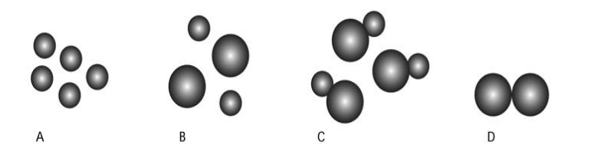

7. Into which two elements can water be broken down?

______________________________________________________________________

8. Describe one features of:

a) Metals

______________________________________________________________________

b) Non-metals

______________________________________________________________________

9.Name the 3 states of matter

______________________________________________________________________

10. Describe what happens when a chemical change takes place

______________________________________________________________________